laura gheorghiu

[Dirección de correo electrónico]

Descripción breve

Motherboard description

modern motherboard

ASRock Fatal1ty Z170 Professional Gaming i7 Motherboard

ASRock Fatal1ty Z170 Professional Gaming i7 Motherboard

The ASRock Fatal1ty Z170 Professional Series Gaming i7 is currently the highest performance gaming motherboard available.It was built for serious gamers with Intel Z170 Chipset.

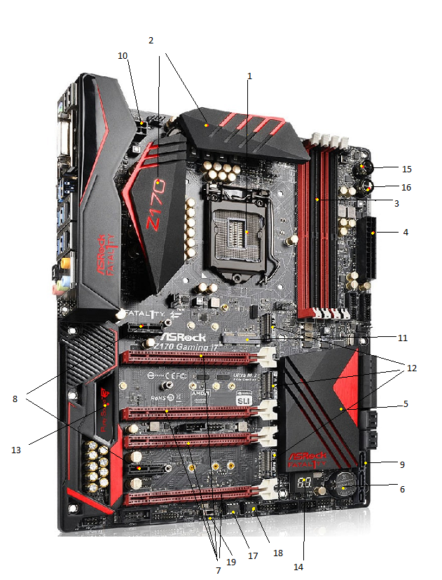

Components:

1. **CPU socket –** is a connector which allows for placing and replacing the microprocessor without soldering. This type of socket is an **LGA** (Land Grid Array);
2. **Heatsink –** a device for absorbing excessive or unwanted heat;
3. **RAM slots-Dual Channel architecture, DDR4;**
4. **ATX 24 pin- Advanced Technology eXtended (ATX) -**Power connector;
5. **Chipset PHP – Platform Controller Hub, Intel Z170;**
6. **CMOS Batery;**
7. **PCIe2, PCIe3,PCIe4,PCIe6 x16 slot-Peripheral Component Interconnect Express-** allows a computer hardware expansion card to be conected;
8. **PCIe1, PCIe5 x1 slot;**
9. **SATA ports- (Serial AT Attachment);**
10. **Extra ATX 8 pin;**
11. **Mini CPIe slot- is used for WiFi module;**
12. **3 Ultra M.2 Sockets-**Next Generation Form Factor**(NGFF)-** support M.2 PCI Express module up to Gen 3x4(32Gb/s);
13. **Purity Sound TM3;**
14. **Dual-digit Post display-**provides code information which makes troubleshooting even easier.
15. **Power Switch;**
16. **Reset Switch;**
17. **BIOS** A led-Basic Input/Output System
18. **BIOS** B led;
19. **BIOS** Selection Switch.

The web site for this motherboard is:

<https://thinkcomputers.org/asrock-announces-the-fatal1ty-z170-professional-gaming-i7-motherboard/>